Tracking sub program balances
November 2015

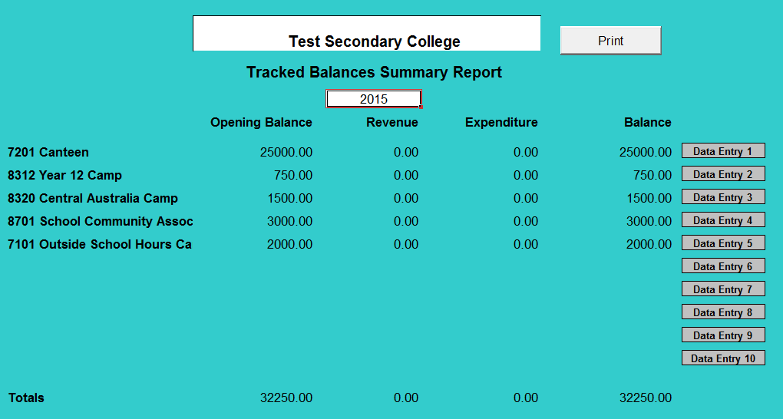
The Tracked Balances Tool contains a separate individual worksheet for each sub program that requires the balance to be tracked. To enter the opening balance select the Data Entry ‘X’ cell and enter details as below.
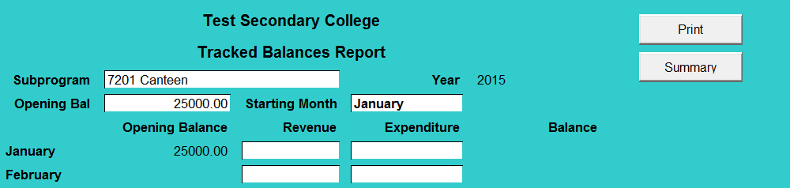
The consolidation of each individual worksheet is contained in the summary worksheet. The example, below displays the layout of the individual worksheet for the 7201 – Canteen Sub Program.

You will note the opening balance figure is ($25,000) brought forward from the previous year.
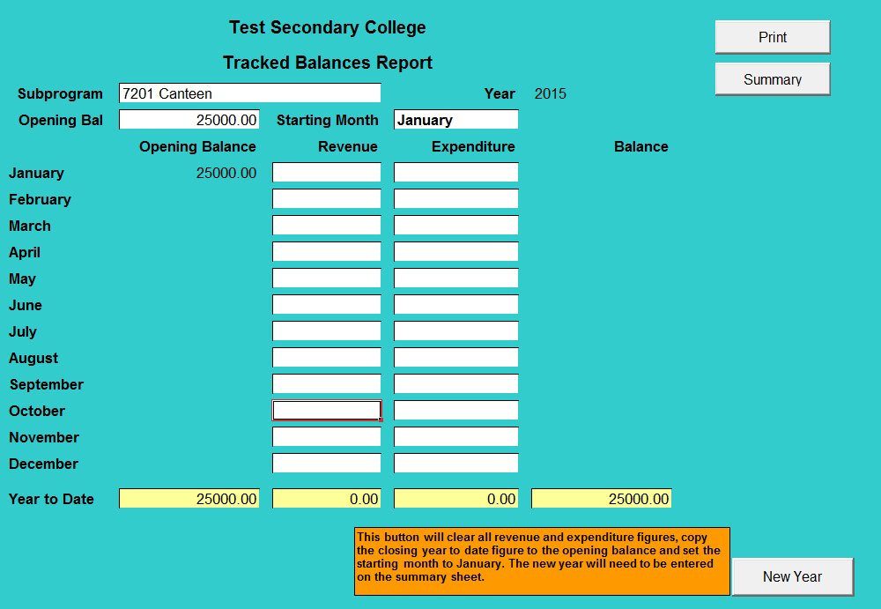
The revenue and expenditure for each month is entered on a monthly basis. As this revenue and expenditure is entered throughout the year, the closing balance will change to reflect the surplus or deficit made for the canteen for the year to date.

An individual report that details all this information can also be printed for each sub program at any time by clicking the Print button. Click the Summary Button to go back to the Summary page and print the Summary Report of all sub programs.

Important Note: Where there is no revenue or expenditure for the month you must enter 0 (do not leave the cell blank).

