Sub Program Report  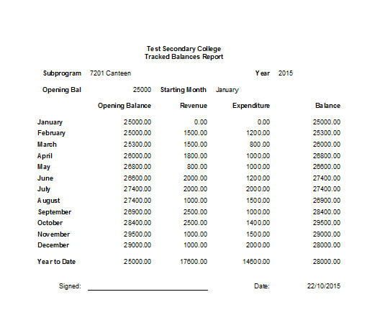 | Tracking sub program balances  November 2015

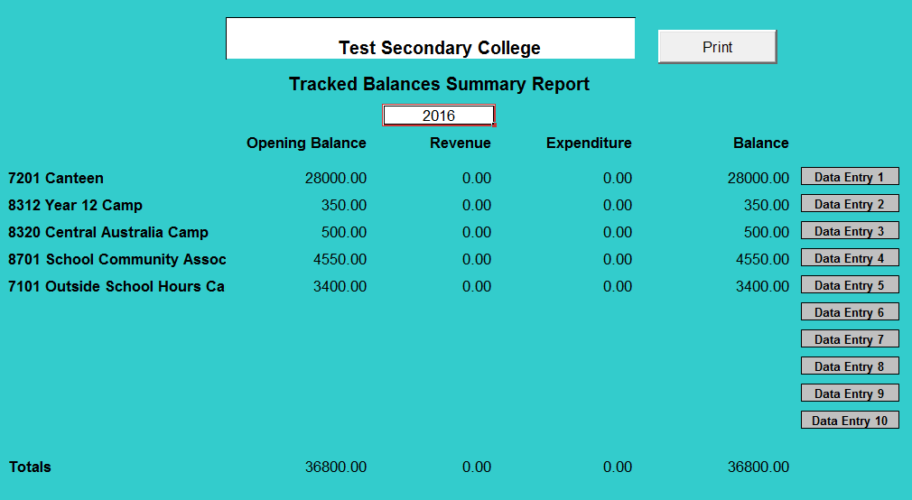

Summary Report

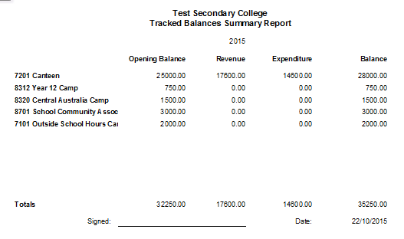

The Tracked Balances Tool contains 10 separate worksheets to track the balances of sub programs. If schools wish to track the balances of more than 10 sub programs separate versions of the tool will need to be used.
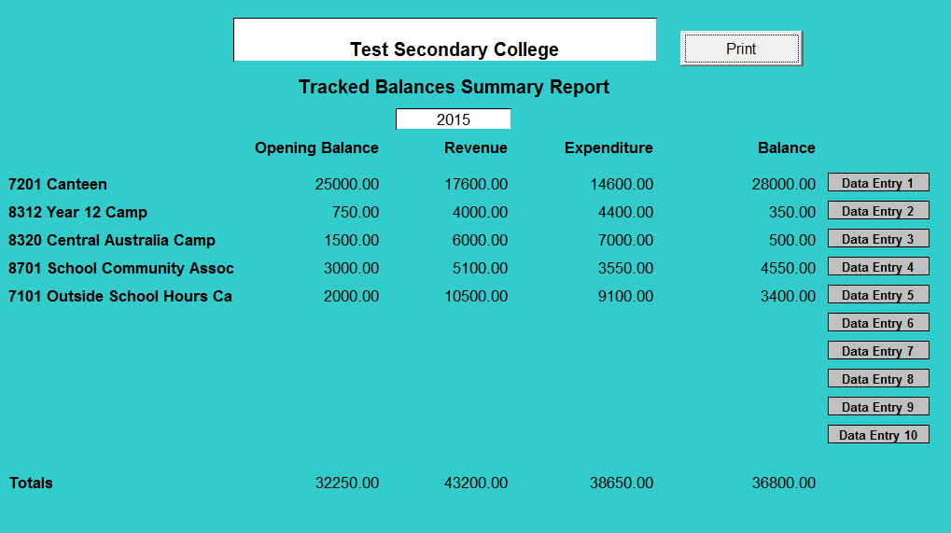
Another feature of the monthly version of the tool is the ability to automatically update a new version of the tool at the end of the year. Click on the ‘New Year’ button and the worksheet will automatically populate the opening balance amount with the closing balance from the previous year, and delete all revenue and expenditure information entered.

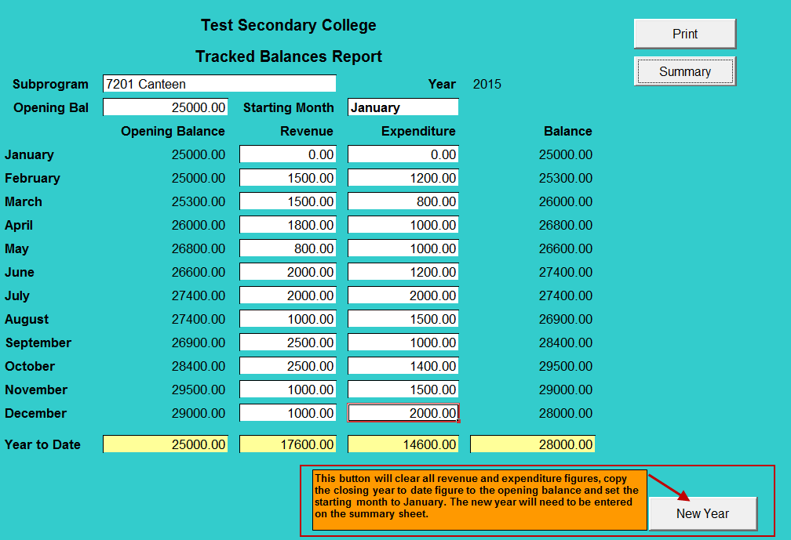
NOTE: Prior to using this function, a copy of the current tool should be saved to ensure adequate records are retained by the school.

The data will be cleared and the closing balance will be displayed in the Opening Bal field for the new year commencing in January.
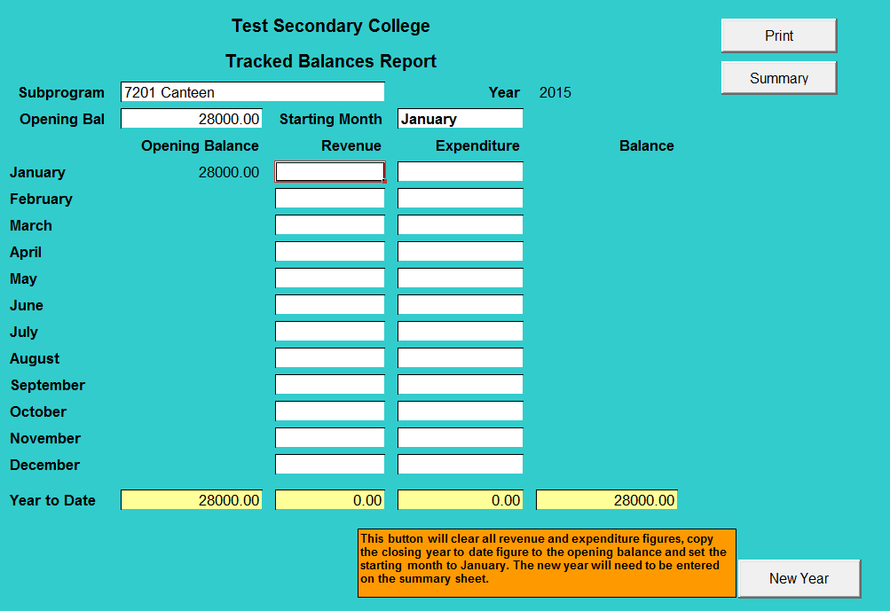

Click the Summary button to go back to the Tracked Balances Summary Report and enter the New Year

