LearnED Introductory Tour
  - Overview of the Department’s Learning Management System

Introduction
LearnED is a central place to plan, manage and document all your learning.
LearnED uses the term Learning Event to collectively refer to all types of learning: classroom training, online learning, one-off sessions, etc.
In LearnED you can:
- view all of your learning events: planned, registered, enrolled, in progress, cancelled and completed
- search the catalogue of learning events
- enrol in learning events
- launch online learning courses
- view the status of mandatory learning programs
- submit reviews of learning events
- add to your learning record any events not listed in the catalogue, for your approver or manager to approve.
If you move around the Department, your learning record will always be in the same place, as you keep the same eduPay account.
This tour overviews LearnED. For more detailed instructions on any of these actions, please refer to the relevant quick reference guide.

Tour Steps
Login to eduPay as usual.
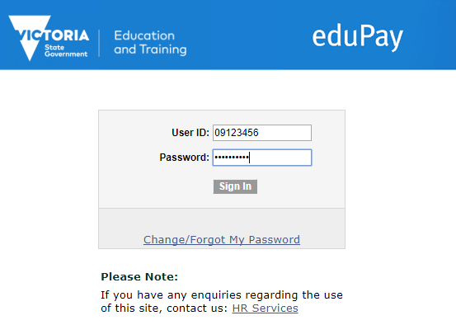
In your Self Service section, select LearnED.
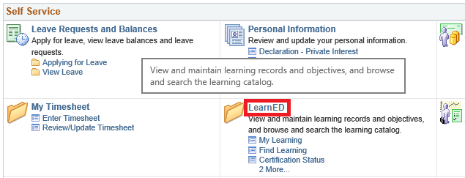
1
There are four main screens to LearnED:
- My Learning: view all learning events planned, registered, enrolled, dropped, in progress, and completed, and you can print certificates
- Find Learning: search the catalogue to add learning to your plans, enrol or launch online learning
- Certification Status: view your mandatory learning’s status and recertification details
- Supplemental Learning: learning not in the catalogue can be submitted to your reviewer or manager to approve if it can be added to your learning records.
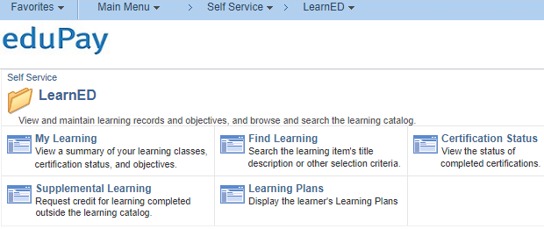
The first screen My Learning is likely to be the screen you use the most.
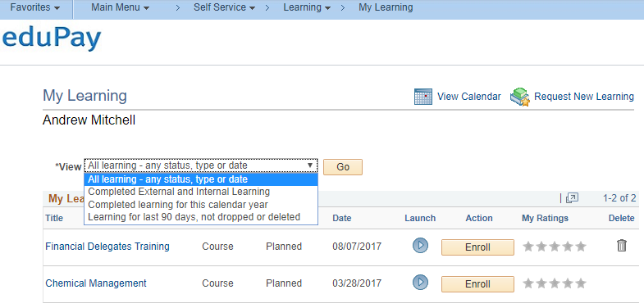
You can use My Learning to view all your learning. Each learning event has a current status, of which most are obvious, only the first three have specific meanings that are worth being aware of:
- Registered – you are registered in a Program of several courses, you must enrol in the specific classes
- Enrolled – you are enrolled in a learning event, you can attend that course or start that online learning
- Dropped – you have decided not to participate in a learning event, your registration is cancelled
- Planned – a learning event has been added to your learning plan, but you are not registered or enrolled
- In Progress – you have started the learning
- Completed – you have completed the learning
On the My Learning screen you can view further details, and by using the Yellow buttons you can: register and enrol in events, launch online learning, submit reviews, and drop events.
Initially your My Learning page my look like this.
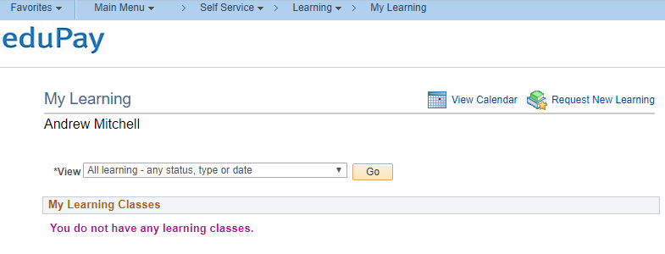
Use the Find Learning screen to search for learning events and then either launch online learning or enrol.
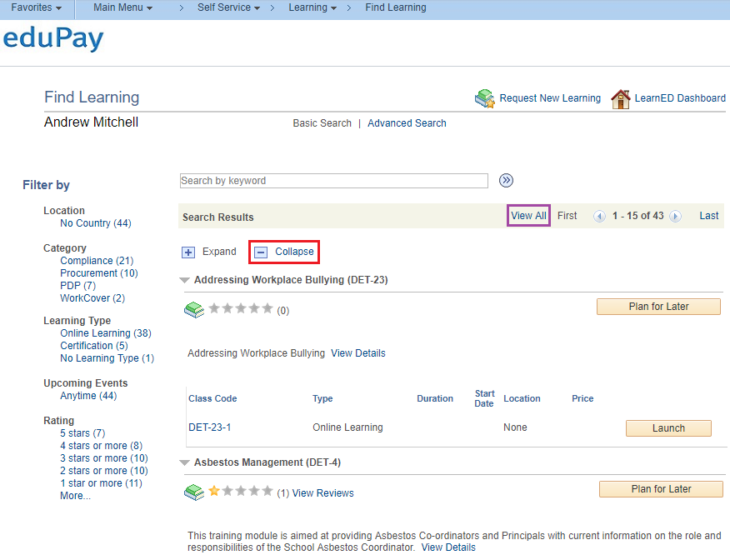
You can both Search by keyword (at top of the screen) and Filter by the various filters (on the left).
Learning events are rated by those that have completed the course in two ways: there is an averaged a 5 star rating and a written review.
Select Collapse (highlighted red) to list just event titles by hiding details. Select View All (highlighted purple) to list all learning, rather than just 15 per page.
There is also an Advanced Search facility (top of screen).
If you are required to complete some learnings within a fixed period of time; for example, some induction Health and Safety courses, in LearnED these may be grouped into a Certification.
The Certification Status screen displays the status of your Certifications.
A Certification can have an expiration date and rules around completion and recertification.
A Certification is useful when you need to obtain a particular certificate, license, skill or competency.
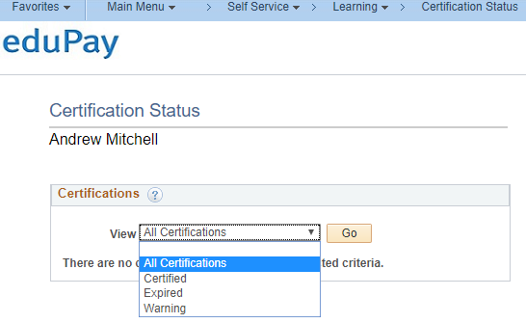
Some learning events relevant to your role (whether already completed or planned for the future) may not be listed in the catalogue. By using the Supplemental Learning screen, you can add these to your learning record, and submit the entry to your manager, whom can then approve the event if it relevant.
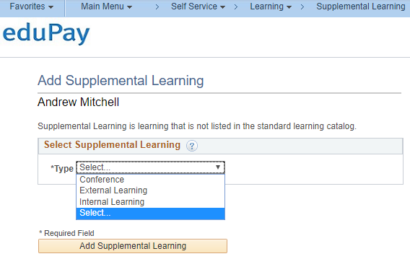
That completes our introductory tour.
Remember there are also Quick Reference Guides on LearnED’s eduGate Support page covering in more detail the details and steps of all you need.

