Find and Enrol in Learning
  - Search the catalogue for courses and other learning events

Introduction
LearnED has a catalogue of learning events. This catalogue can be searched in a number of ways. When you have found the relevant learning event, you can: add the learning to your plan for later, enrol in the event, or launch online learning immediately.

Quick Steps
Go to the Find Learning page.
Do this either from the Self Service section on your eduPay homepage,
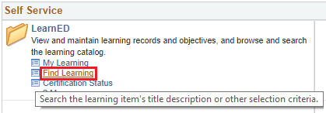
or, by selecting Main Menu, Self Service, LearnED, Find Learning.
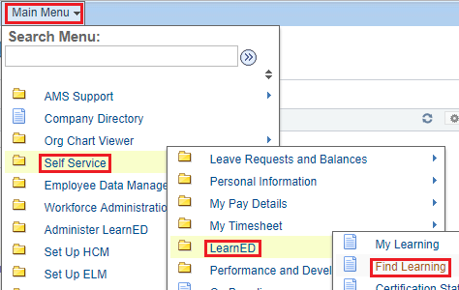
You can search for learning using either the Basic Search (covered here) or Advanced Search (see Step 12 on page 8).
Basic Search uses two search methods together:
- Text search: type one word or more in the Search by keyword box (highlighted red below) then press the Enter key to see which events contain those words
- Select a Filter (highlighted purple) to display just that category of learning events.
Note: Filters may have sub-filters; for example, the Compliance category has subcategories of Induction and OH&S.
Both of these search methods are used together; for example, select Compliance then keyword search within those 21 courses.
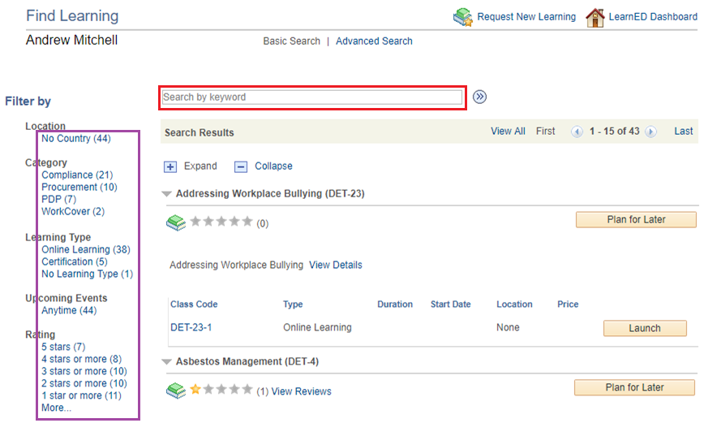
Look at the results.
Word searching finds events containing all those words mentioned anywhere in the learning event’s details; for example, the first course below has management in the Title, the second course has management in the Details.
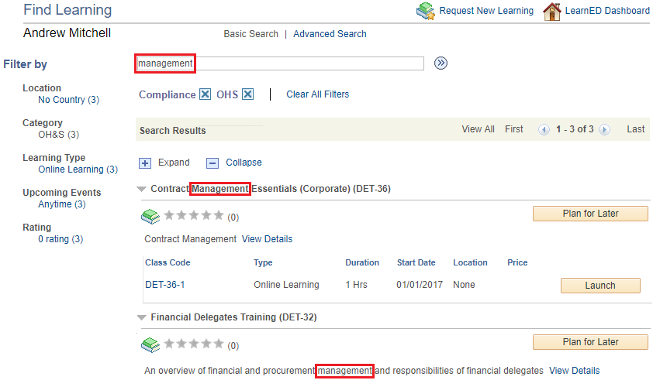
If you have not yet found what you are looking for, adjusting your search is easy.
To edit the search words: click in the search box to edit the words. (Click at the end of the box to place the cursor at the end of the last word. Click on a letter to place the cursor immediately before that character.)
To clear all search words: select the search box by clicking in it, select all the text (Ctrl-A), then press either the Backspace or the Delete key.
To clear a filter: click on the X after the filter to clear it (orange box).
The Clear All Filters button has the same effect as selecting the X after first filter (purple boxes).
Note: Clearing filters does not clear the search text.
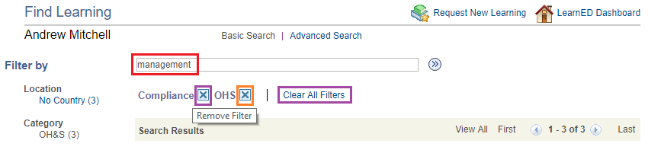
Select View Details to view more event details.
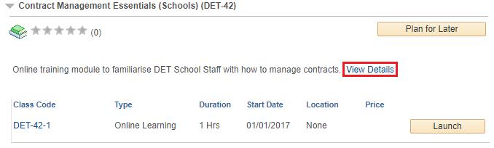
Select Return to Previous Page to return to your search results.
You can also select any of the appropriate buttons at the bottom of the page.
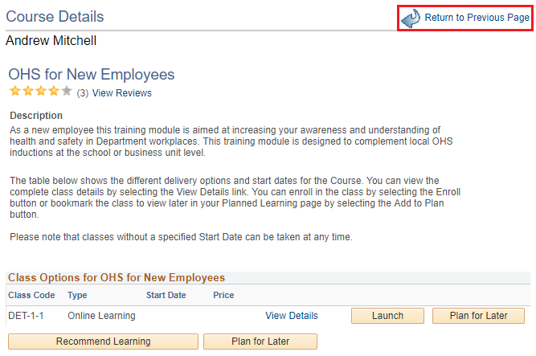
Select View Reviews to read Reviews.
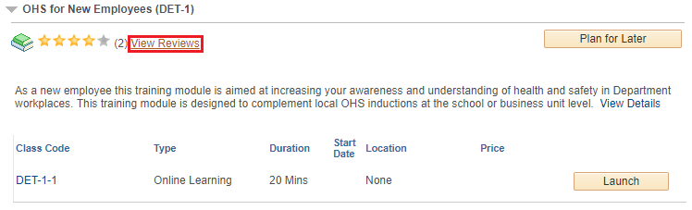
Select Close button after reading reviews.
If a review contains content that is not appropriate, select Flag Review (highlighted purple), this hides the review and notifies this event’s Learning Administrator.
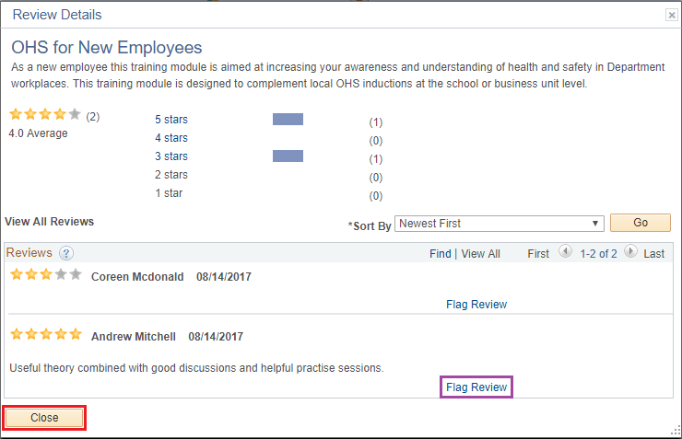
Select Yes button to confirm this action.
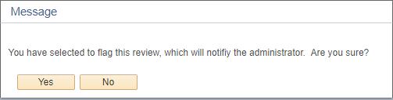
To add learning to your plan, select the Plan for Later button or the Register button.
To launch online learning immediately, select the Launch button. Launching an event will automatically enrol you.
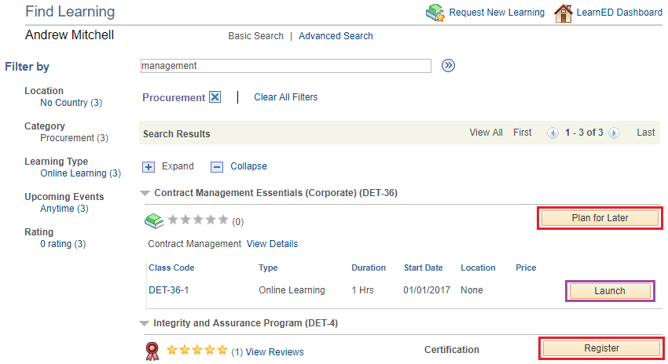
If you selected the Plan for Later button, fill in the form as appropriate, and select the Save button.
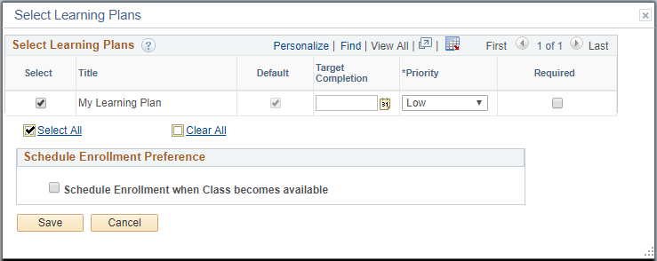
If you selected the Register button, displayed will be confirmation that you have succeeded.
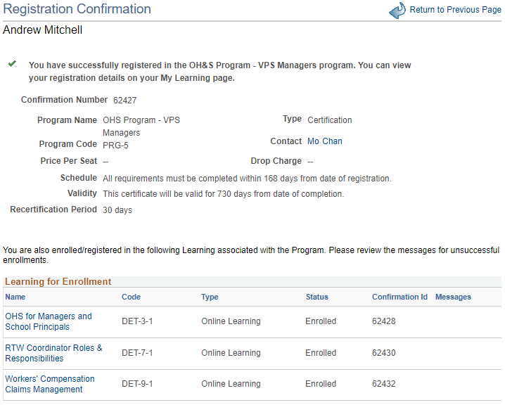
Select Advanced Search to perform more selective searches.
The question mark symbol (highlighted purple) displays help on both the mechanics of the Basic Search and extensive explanations of the Advanced Search tex t searches.
